**Front End Web Development**

**Project 3**

**S. Bacot**

**NOTES & CREDITS**

1. **RESTAURANT PAGE**

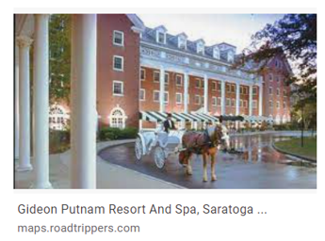

"img/gideonputnamentrancenight2.jpg" (cCegQIABAA&oq=images%2C+gideon+putnam&gs_lcp=CgNpbWcQA1ChNVi3c2CJdmgAcAB4AIABf4gBzQ2SAQQyMS4xmAEAoAEBqgELZ3dzLXdpei1pbWfAAQE&sclient=img&ei=OgMCYtnrM_DgytMPz9qywAU&bih=641&biw=1422&rlz=1C1JZAP_enUS894US894)

**2.**

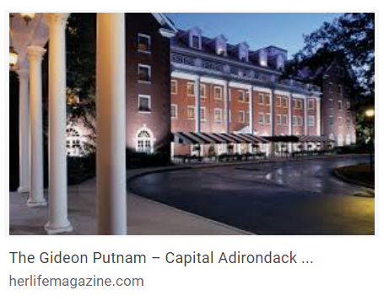

"img/gideonputnamentrancenight3.jpg"

(<https://www.google.com/search?q=images%2C+gideon+putnam&tbm=isch&ved=2ahUKEwjZ8KKus-_1AhVwsHIEHU-tDFgQ2-cCegQIABAA&oq=images%2C+gideon+putnam&gs_lcp=CgNpbWcQA1ChNVi3c2CJdmgAcAB4AIABf4gBzQ2SAQQyMS4xmAEAoAEBqgELZ3dzLXdpei1pbWfAAQE&sclient=img&ei=OgMCYtnrM_DgytMPz9qywAU&bih=641&biw=1422&rlz=1C1JZAP_enUS894US894>)

**3.**

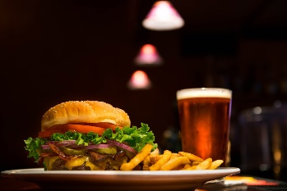

“edward-franklin-Nb_Q-M3Cdzg-unsplash Burger and Beer 2 6 22.jpg”

**Edward Franklin,** Download free, beautiful high-quality photos curated by Edward. [Eugene, OR](https://unsplash.com/s/photos/eugene%2C-or) [Instagram](https://instagram.com/eddie2oh) (<https://images.unsplash.com/photo-1457460866886-40ef8d4b42a0?ixlib=rb-1.2.1&ixid=MnwxMjA3fDB8MHxzZWFyY2h8MXx8YnVyZ2VyJTIwYW5kJTIwYmVlcnxlbnwwfHwwfHw%3D&auto=format&fit=crop&w=600&q=60>)

**4.**

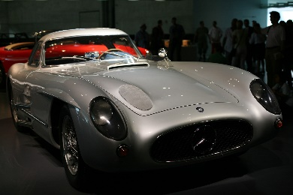

"img/automobile-gfed46634e_1920 museum car 2 2 22.jpg" (<https://pixabay.com/photos/automobile-sports-car-mercedes-6067731/>)

**5.**

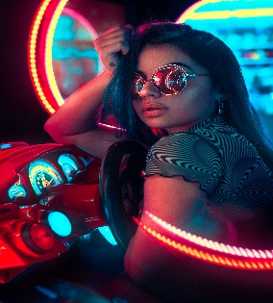

"img/wilmer-martinez-zLlXblupecM-unsplash arcade1 2 7 22.jpg," Photo by [Wilmer Martinez](https://unsplash.com/@wilmerlens?utm_source=unsplash&utm_medium=referral&utm_content=creditCopyText) on [Unsplash](https://unsplash.com/s/photos/arcade?utm_source=unsplash&utm_medium=referral&utm_content=creditCopyText) (<https://images.unsplash.com/photo-1580428180123-313752d0f0f3?ixlib=rb-1.2.1&ixid=MnwxMjA3fDB8MHxwcm9maWxlLXBhZ2V8Nnx8fGVufDB8fHx8&auto=format&fit=crop&w=600&q=60>)

**6.**

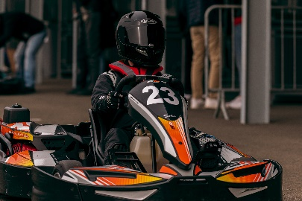 **Bastien Plu-**I'm photographer living in France. I've many field like sport, corporate, portrait, wildlife, animal and more. You can see a lot of my work here and on my different link. <https://linktr.ee/BastienPluPhotographe>, Available for hire

[Support via PayPal](https://www.paypal.com/donate?business=bastien.plu%40icloud.com&item_name=Bastien%20Plu%20-%20Unsplash&currency_code=USD)

[Le Mans, France](https://unsplash.com/s/photos/le-mans%2C-france)

"img/bastien-plu-CUt2SVsDbk4-unsplash kart racer2 2 6 22.jpg" (https://images.unsplash.com/photo-1641473076702-e9fed7a169a4?ixlib=rb-1.2.1&ixid=MnwxMjA3fDB8MHxzZWFyY2h8MTN8fGthcnQlMjByYWNlcnxlbnwwfHwwfHw%3D&auto=format&fit=crop&w=600&q=60)

**7.**

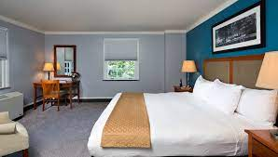

"img/gideonputnam-putnam-suite-2-lg.jpg"

(https://www.google.com/search?q=images%2C+gideon+putnam&tbm=isch&ved=2ahUKEwjZ8KKus-_1AhVwsHIEHU-tDFgQ2-cCegQIABAA&oq=images%2C+gideon+putnam&gs_lcp=CgNpbWcQA1ChNVi3c2CJdmgAcAB4AIABf4gBzQ2SAQQyMS4xmAEAoAEBqgELZ3dzLXdpei1pbWfAAQE&sclient=img&ei=OgMCYtnrM_DgytMPz9qywAU&bih=641&biw=1422&rlz=1C1JZAP_enUS894US894)

**8.**

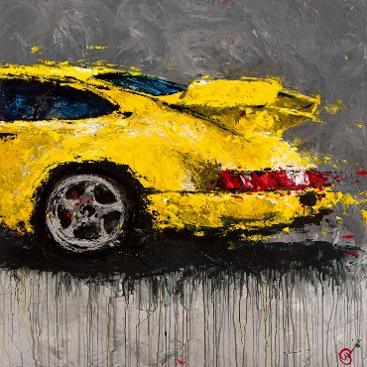Abstracted Air - The Artwork Of Lyn Hiner On Display

Featuring the varied paintings of celebrated automotive artist Lyn Hiner.

"img/ABSTRACTED AIR BY LYN HINER.png" (http://www.saratogaautomuseum.org/current-exhibitions)

1. **MENU PAGE**

**1.**

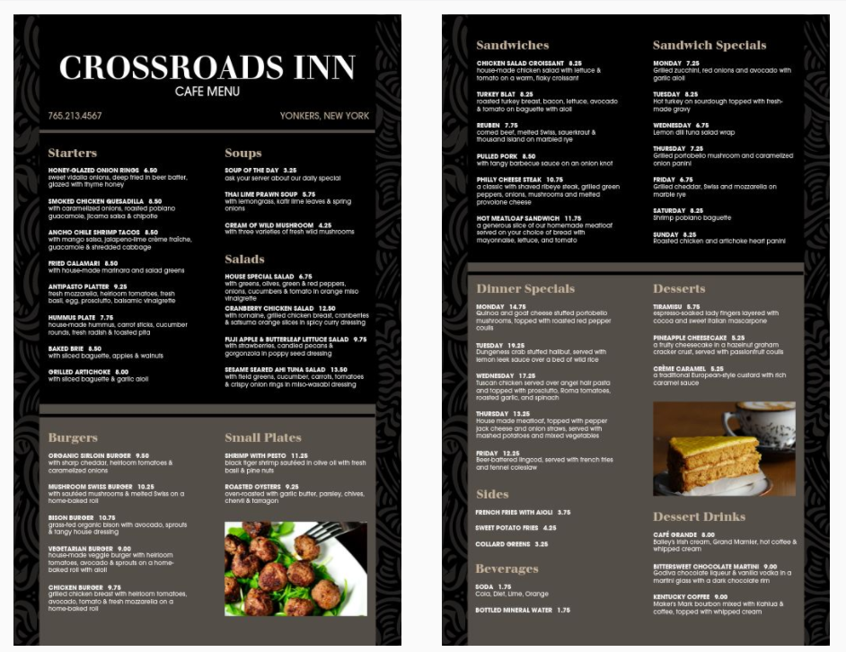

“https://renderer.mhme.nu/design/thumbnail/15fd0406-d7fe-4f8f-a8e7-89685b7ee8a9?width=500&update=1644271615419&page=2”

https://www.musthavemenus.com/menu-template/elegant-hotel-menu.html?cat=7534

1. **ACTIVITIES PAGE**

**1.**

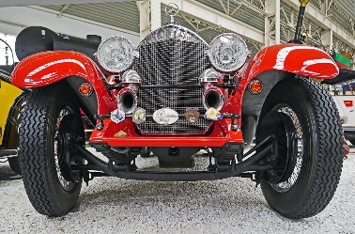

"img/mercedes-g83c817a30_1920 museum car 2 2 22.jpg" (<https://pixabay.com/photos/mercedes-spider-roadster-race-car-1336383/>)

**2.**

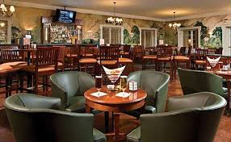

"img/gideonputnamgreenlounge.jpg" (<https://www.google.com/search?q=images%2C+gideon+putnam&tbm=isch&ved=2ahUKEwjZ8KKus-_1AhVwsHIEHU-tDFgQ2-cCegQIABAA&oq=images%2C+gideon+putnam&gs_lcp=CgNpbWcQA1ChNVi3c2CJdmgAcAB4AIABf4gBzQ2SAQQyMS4xmAEAoAEBqgELZ3dzLXdpei1pbWfAAQE&sclient=img&ei=OgMCYtnrM_DgytMPz9qywAU&bih=641&biw=1422&rlz=1C1JZAP_enUS894US894>)

**3.**

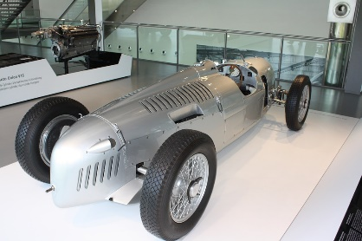

"img/automuseumracecarsilver.jpg" (<https://pixabay.com/photos/autostadt-wolfsburg-wolfsburg-museum-1104140/>)

**4.**

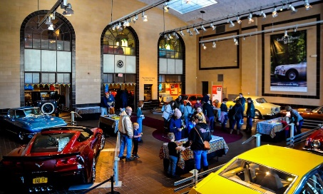

"img/Racehouseentrance2.jpg" (https://saratogaliving.com/wp-content/uploads/2020/01/image001-1.jpg)

**5.**

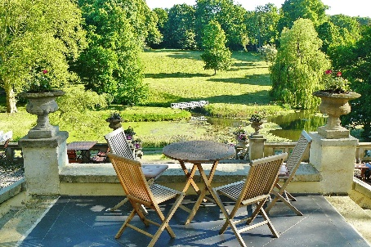

"img/castle-park-gbb5ef33de_1920 dining outside1 2 7 22.jpg" (<https://pixabay.com/photos/castle-park-hotel-terrace-park-806854/>)

**6.**

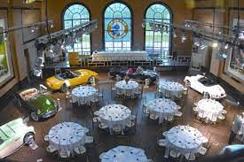

"img/Racehousedining1.jpg" (https://images.squarespace-cdn.com/content/v1/521f4119e4b0609085e5ab68/1407766228782-L816RZZDRLZPOYXBA02B/image-asset.jpeg)

**7.**

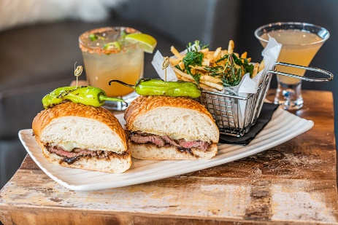

Photo by [Hybrid Storytellers](https://unsplash.com/@hybridstorytellers?utm_source=unsplash&utm_medium=referral&utm_content=creditCopyText) on [Unsplash](https://unsplash.com/s/photos/sports%2Bbar?utm_source=unsplash&utm_medium=referral&utm_content=creditCopyText), "img/hybrid-storytellers-DrdtArh85b4-unsplash sports bar food 2 8 22.jpg"( https://unsplash.com/photos/DrdtArh85b4)

**8.**

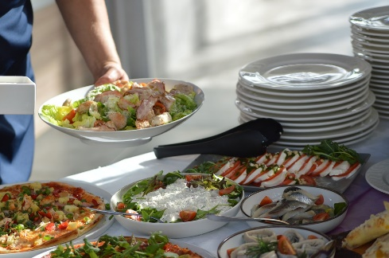

"img/salad-gf85b752c1_1920 dining salads 2 7 22.jpg" (https://pixabay.com/photos/salad-table-brunch-setting-dining-1684468/)

**9.**

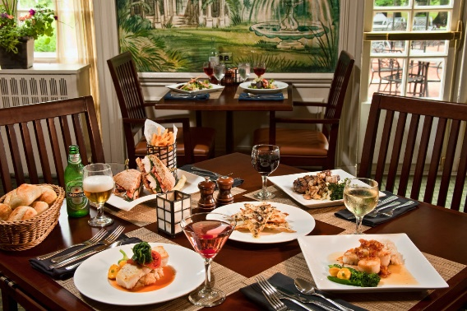

"img/Racehousefood.jpg" (https://assets.simpleviewinc.com/simpleview/image/fetch/c_limit,q_80,w_1200/https://assets.simpleviewinc.com/simpleview/image/upload/crm/saratoga/2015-01-Putnams-Food-Tables_202482a3-f44d-306e-38033714d345cd24.jpg)

**10.**

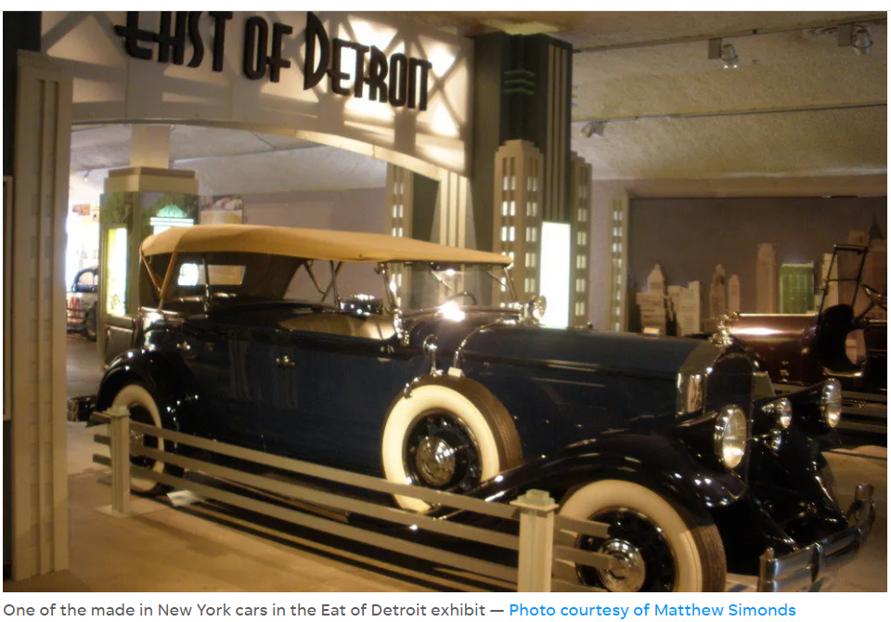

"img/Classiccar1.png" (<https://img1.10bestmedia.com/Images/Photos/219343/p-025_54_990x660_201404240217.jpg>)

**11.**

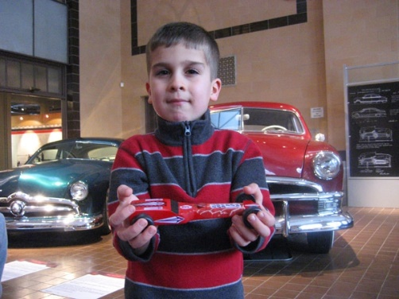

"img/kidwithcars.jpg" (<https://www.discoverupstateny.com/images/products/SaratogaAutomobileMuseum5.jpg>)

**12.**

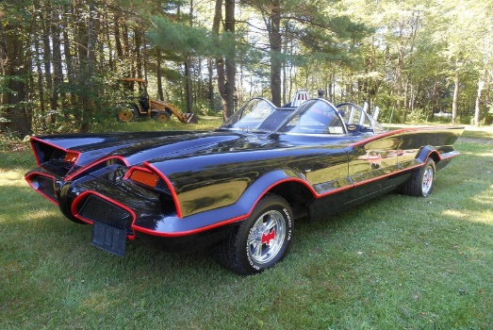 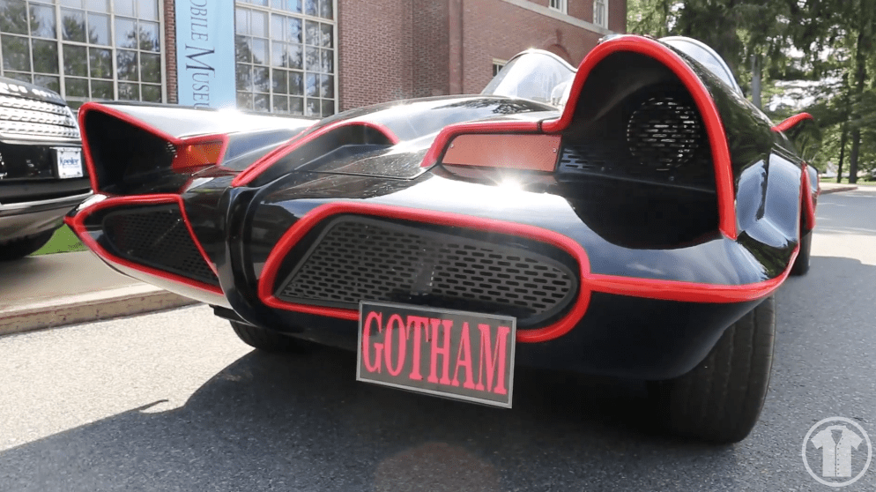

"img/batmobile.jpg" Gotham image not included (https://miro.medium.com/max/790/1*GGfB1zRoERWLd1oowdgesQ.jpeg)

(<https://i0.wp.com/www.twobuttonsdeep.com/wp-content/uploads/2018/09/Screen-Shot-2018-09-18-at-9.07.49-PM.png?resize=994%2C558&ssl=1>)

**13.**

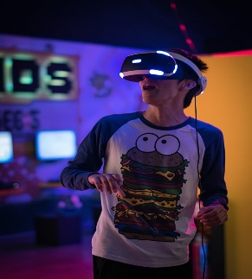

"img/uriel-soberanes-MxVkWPiJALs-unsplash arcade4 2 7 22.jpg"

Photo by [Uriel Soberanes](https://unsplash.com/@soberanes?utm_source=unsplash&utm_medium=referral&utm_content=creditCopyText) on [Unsplash](https://unsplash.com/s/photos/arcade?utm_source=unsplash&utm_medium=referral&utm_content=creditCopyText) (<https://unsplash.com/photos/MxVkWPiJALs>)

**14.**

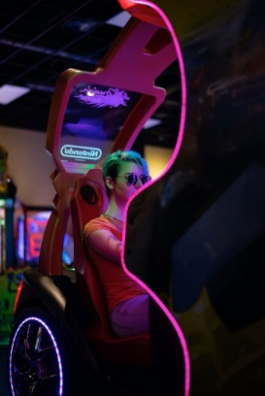

"img/ashley-byrd-sZjvqAfPpuM-unsplash arcade5 2 7 22.jpg"

Photo by [Ashley Byrd](https://unsplash.com/@byrdman85?utm_source=unsplash&utm_medium=referral&utm_content=creditCopyText) on [Unsplash](https://unsplash.com/s/photos/arcade?utm_source=unsplash&utm_medium=referral&utm_content=creditCopyText) (https://unsplash.com/photos/sZjvqAfPpuM)

**15.**

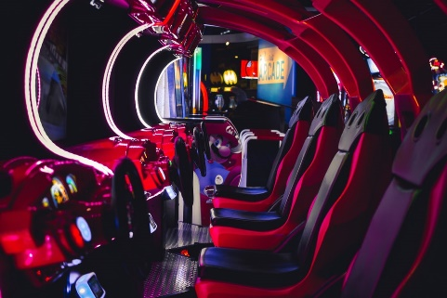

"img/shamir-hunley-Sp0B6PR95EI-unsplash arcade2 2 7 22.jpg"

Photo by Shamir Hunley (https://unsplash.com/photos/Sp0B6PR95EI)

**16.**

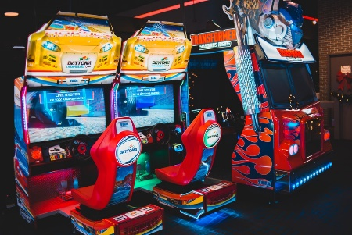

"img/erik-mclean-359yV-5925c-unsplash arcade3 2 7 22.jpg"

Donations are welcome! paypal.me/Introspectivedsgn

& Feel free to reach out if you wish to purchase selling rights. Give me a follow on instagram @introspectivedsgn

Available for hire

Support via PayPal

st. Johns, NL

Photo by Erik Mclean (<https://unsplash.com/photos/359yV-5925c>)

**17.**

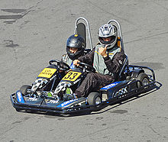

"img/doublegokart.jpg"

This image as well as specific information on Go Karts, engines, tracks were obtained from Wikipedia. (https://en.wikipedia.org/wiki/Go-kart)

**18.**

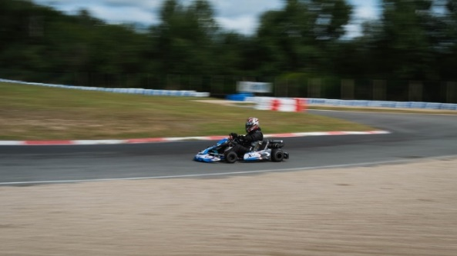

"img/nicolas-peyrol-NZoDftEmEp0-unsplash kart racer4 2 6 22.jpg"

Photo by [Nicolas Peyrol](https://unsplash.com/@nicolaspeyrol?utm_source=unsplash&utm_medium=referral&utm_content=creditCopyText) on [Unsplash](https://unsplash.com/s/photos/kart-race?utm_source=unsplash&utm_medium=referral&utm_content=creditCopyText)

(<https://unsplash.com/photos/NZoDftEmEp0>)

**19.**

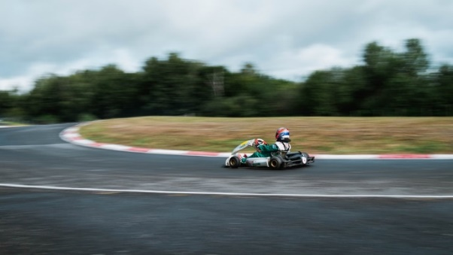

"img/nicolas-peyrol-Ino6sZOJc-k-unsplash kart racer5 2 6 22.jpg"

Photo by [Nicolas Peyrol](https://unsplash.com/@nicolaspeyrol?utm_source=unsplash&utm_medium=referral&utm_content=creditCopyText) on [Unsplash](https://unsplash.com/s/photos/kart-race?utm_source=unsplash&utm_medium=referral&utm_content=creditCopyText)

(<https://unsplash.com/photos/Ino6sZOJc-k>)

**20.**

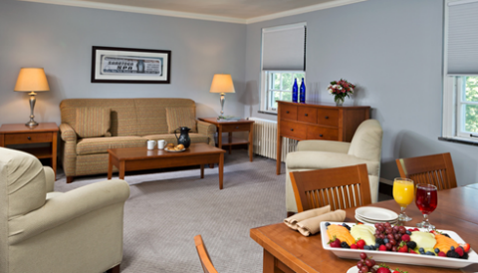 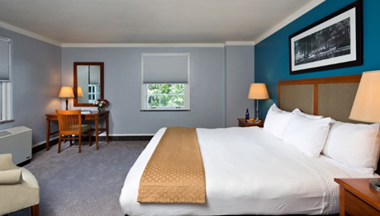 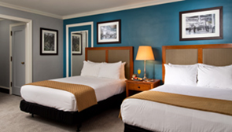

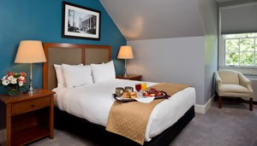 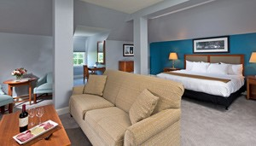 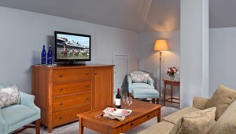

"img/gideonputnam-putnam-suite-1-lg.jpg"

"img/gideonputnam-putnam-suite-2-lg.jpg

"img/gideonputnam-putnam-suite-3-lg.jpg

"img/gideonputnam-putnam-suite-4-lg.jpg

"img/gideonputnam-putnam-suite-5-lg.jpg

"img/gideonputnam-putnam-suite-6-lg.jpg"

https://www.gideonputnam.com/lodging-and-dining/room-types

1. **LOCATION PAGE**

**1.**



"img/Race House Map2.pdf"

https://www.google.com/maps/@43.055452,-73.8024114,16.25z?hl=en&authuser=0

**2.**

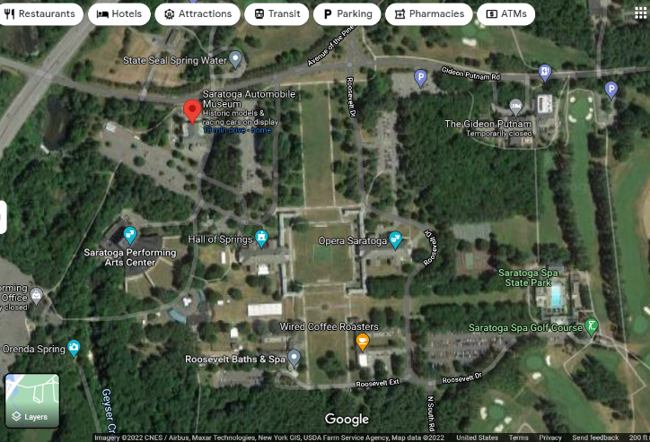

"img/map AutoMuseum.png"

<https://www.google.com/maps/place/Saratoga+Automobile+Museum/@43.0557993,-73.8044725,725m/data=!3m1!1e3!4m5!3m4!1s0x0:0x6e9c36d2d1235f82!8m2!3d43.0571535!4d-73.8047019>

**3.**

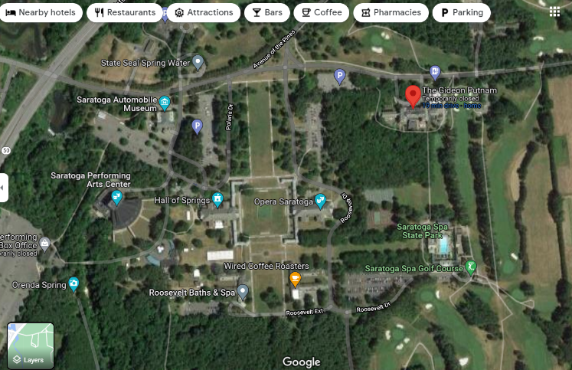

"img/map GideonPutnam.png"

<https://www.google.com/maps/place/The+Gideon+Putnam/@43.0557359,-73.8043467,813m/data=!3m1!1e3!4m8!3m7!1s0x89de38515b18b8bd:0x6ac4404b70fdbe1d!5m2!4m1!1i2!8m2!3d43.0572383!4d-73.7982997>

**4.**

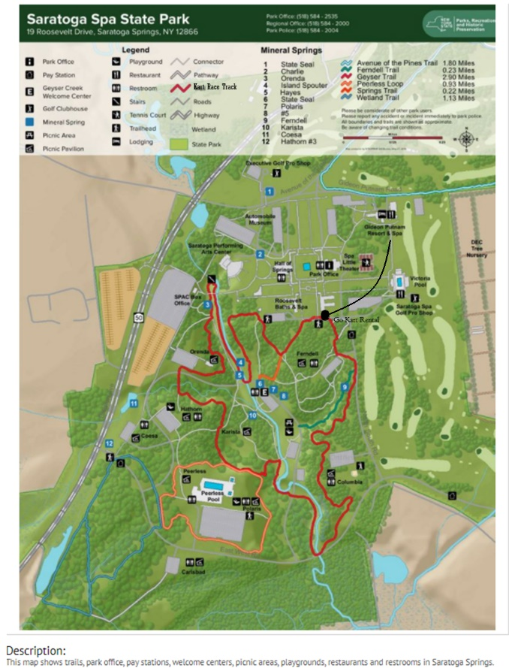

"img/map StateSpaPark2.png"

https://ontheworldmap.com/usa/city/saratoga-springs/saratoga-spa-state-park-map.html

1. **ACCESSIBILITY PAGE**

**1.**

Some wording was taken directly from Gideon Putnam’s accessibility website content.

<https://www.gideonputnam.com/accessibility-statement>

**2.**

Some information was referenced from “[The Website Accessibility Checklist](https://www.boia.org/e3t/Btc/5A+113/ckxm204/VXgV7c7-VGb_W3vVnt06FpnWVW48Yhp74FjcpVN6wcHq13lLB3V1-WJV7CgNZ9W80ZDqj6t5yTKW8RnFct3tPp-5MjbrXwjqRbZW9gl_5q8CrDBTW5YrjdX6h2TCGN2RRt6_Z6xfDW2FJQwx7s1HmBW938NnW25_d1SW69L1Ld7fblB7W8-tvxk1cf2f1W81kQ115pbs0fW8ZhKQr8m31QNW8G0q4s6fHCHXW6SwB_85dG87DW44RQXj6N_0TFW1Z72Sd7Hcf1WW5zRB2V1MyDF7W7R9Fw04l-fy0W2VwMjB2rNrPmW8n2BQ15_4Pxd31qP1),” published by the Bureau of Internet Accessibility Inc. (BOIA) 2021.

<https://boia.docsend.com/view/vwmnvs8?utm_medium=email&_hsmi=172172853&_hsenc=p2ANqtz-86n2c49TKXBtAPbfpAuZCGknKyIVuvqpFQYTrt_zOawKPG7je5JQzv9DG7N6rdLuBtTg7gA2JOkPp3vDC2O3-XlqQ08Q&utm_content=172172853&utm_source=hs_automation>

**3.**

Website scanning performed by Bureau of Internet Accessibility Inc. (BOIA) February 17, 2022.

**4.**

Referenced “5 Quick Ways to Self-check the Accessibility of a Website.”

<https://www.boia.org/blog/5-quick-ways-to-self-check-the-accessibility-of-a-website>

**5.**

Referenced “8 Free Web-Based Website Accessibility Evaluation Tools,”

By Justin Mifsud.

<https://usabilitygeek.com/10-free-web-based-web-site-accessibility-evaluation-tools/>